TASK - 4

Hiring Process Analytics

# Project Description:

The MNCs or any company learn about the key underlying patterns of that recruitment in the hiring process. In this project, as I understand it to be, is the analytics of the hiring process which is the foundational and crucial part of any business. It is also obvious that corporations should carefully consider trends before recruiting freshmen or anybody else, including all the details that come into play. Hence, it is the job of the data analyst to examine these trends and derive conclusions which the hiring department may use.

# Approach:

For this project as there happens to be only one dataset it is best to go with a sequential approach which will help me have better coherence and cohesion with the topic and the task.

# Tech Stack:

Language: Structured Query Language [S.Q.L.]

Software used: MySQL

Version: 8.0.30

Original Author: MySQL AB

Developer: ORACLE Corporation

Latest Stable Release: 6th July 2022

Purpose: To run and execute SQL Commands.

# Task/Solution:

**All the solutions can be found in the .xlsx file in the same drive folder from the cell K5 along with the dataset for better understanding.**

1. **Hiring:** Process of intaking people into an organization for different kinds of positions.  
   How many males and females are Hired ?

Sol: The no. of males and females can be found using:

=COUNTIF(D2:D7169,"Male")

=COUNTIF(D2:D7169,"Female")

| A. | Male Employes | 4085 |
| --- | --- | --- |
|  | Female Employees | 2675 |

1. **Average Salary:** Adding all the salaries for a select group of employees and then dividing the sum by the number of employees in the group.  
   What is the average salary offered in this company ?

Sol: The average salary can be found using:

=AVERAGE(G2:G7169)

| B. | Average Salary | 49983.02902 |
| --- | --- | --- |

1. **Class Intervals:** The class interval is the difference between the upper class limit and the lower class limit.  
   Draw the class intervals for salary in the company ?

Sol: The class interval of salary can be found by:

=MAX(G2:G7169)-MIN(G2:G7169)

| C. | Class Interval of Salary | 399900 |
| --- | --- | --- |

1. **Charts and Plots:** This is one of the most important parts of analysis to visualize the data.  
   Draw Pie Chart / Bar Graph ( or any other graph ) to show the proportion of people working in different departments ?

Sol:

| D. | Bar Graph Showing Department |
| --- | --- |

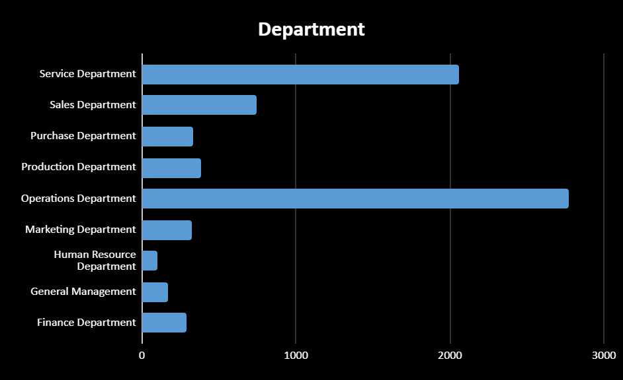

1. **Charts:** Use different charts and graphs to perform the task representing the data.  
   Represent different post tiers using a chart/graph?

Sol:

| E. | Graph Showing Post Tiers: |
| --- | --- |

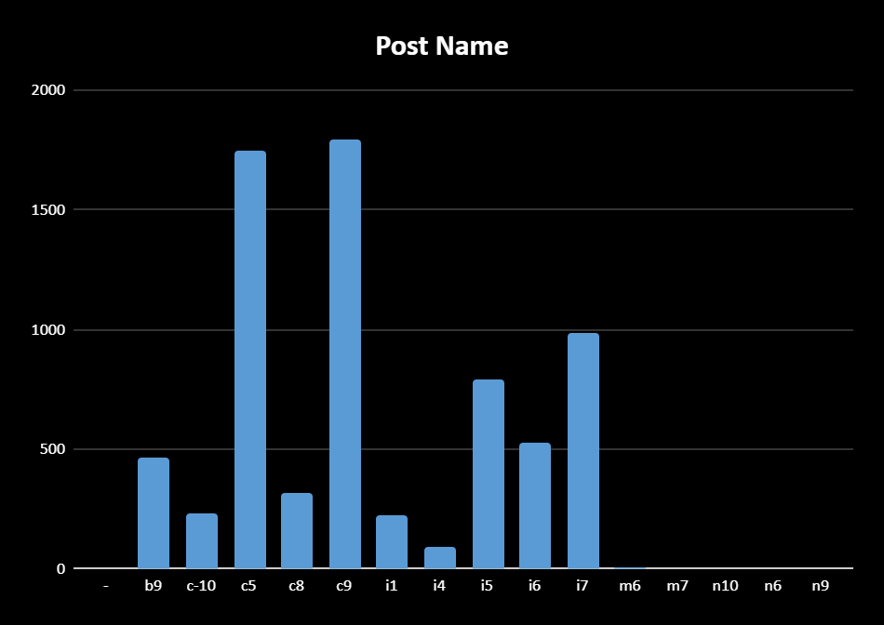

# Insights:

Insights refers to accurate understanding of something. These points helps in an insightful understanding of the problems:

* All the problems refer to real-life situations which any data analyst would face while dealing with data. The attributes may differ but the application or approach will not change.
* Here we have only one dataset which shows the data of a company with different features
* The attributes include: id, interview date and time, status, gender, department, position, salary.
* There are around 7169 records with some missing values in various attributes.
* Using basic formulas in Excel like count, average, min, max we can solve the given scenarios with ease.

# 

# Result:

To recapitulate, the results are elaborately discussed above, moreover this project/task helped me in better understanding of Excel formulae and working with Excel sheets. It also enhanced my Critical Thinking and Problem-Solving skills. (I could not solve all the questions by using joins. However I managed to draw conclusions using other concepts which are hopefully right).

Thank You.